ORDERS,CUST,SALESPEOPLE

- Create the Salespeople as below screenshot.
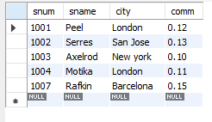

- Create the Cust Table as below Screenshot 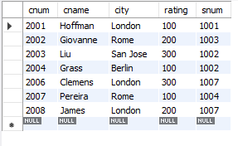
- Create orders table as below screenshot.
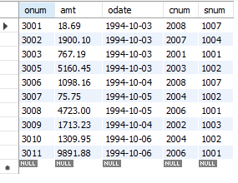
- Write a query to match the salespeople to the customers according to the city they are living.

- Write a query to select the names of customers and the salespersons who are providing service to them.

- Write a query to find out all orders by customers not located in the same cities as that of their salespeople

- Write a query that lists each order number followed by name of customer who made that order

- Write a query that finds all pairs of customers having the same rating………………

- Write a query to find out all pairs of customers served by a single salesperson………………..

- Write a query that produces all pairs of salespeople who are living in same city………………..

- Write a Query to find all orders credited to the same salesperson who services Customer 2008

- Write a Query to find out all orders that are greater than the average for Oct 4th

- Write a Query to find all orders attributed to salespeople in London.
- Write a query to find all the customers whose cnum is 1000 above the snum of Serres.
- Write a query to count customers with ratings above San Jose’s average rating.
- Write a query to show each salesperson with multiple customers.

